M Mohamed Sherif
Day 37 - React Task

Folder Structure
src/
├── Day37/
│ └── MoodBoard.jsx
├── App.jsx
└── main.jsx
MoodBoard.jsx
import { useState } from "react";
function MoodBoard() {
const [mood, setMood] = useState("");
const [darkMode, setDarkMode] = useState(false);
return (
<div
style={{
backgroundColor: darkMode ? "#1e1e2f" : "#fff8dc",
color: darkMode ? "white" : "black",
minHeight: "100vh",
textAlign: "center",
padding: "40px"
}}
>
<h1>My Mood Board</h1>
<h2>How are you feeling today?</h2>
<input
type="text"
placeholder="Type your mood..."
value={mood}
onChange={(e) => setMood(e.target.value)}
style={{ padding: "10px", width: "250px", fontSize: "16px" }}
/>
<h3>
Your Mood: {mood ? mood : " Waiting for your mood..."}
</h3>
<button
onClick={() => setDarkMode(!darkMode)}
style={{ padding: "10px 20px", marginTop: "20px", fontSize: "16px" }}
>
{darkMode ? "Day Mode" : " Night Mode"}
</button>
</div>
);
}
export default MoodBoard;
App.jsx
import MoodBoard from "./Day37/MoodBoard";
function App() {
return <MoodBoard />;
}
export default App;
main.jsx (No Change)
import React from "react";
import ReactDOM from "react-dom/client";
import App from "./App";
ReactDOM.createRoot(document.getElementById("root")).render(
<App />
);

Output:
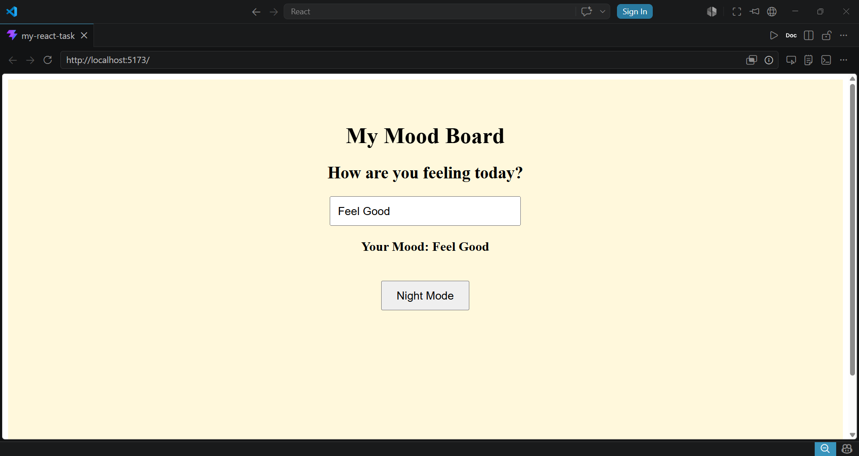

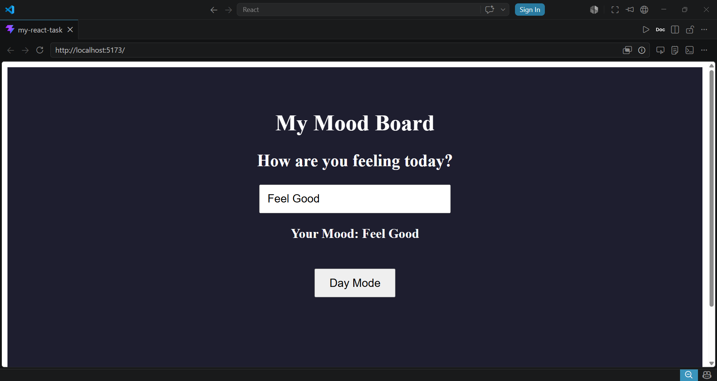-z

